UNIVERSITATEA POLITEHNICA BUCUREŞTI

FACULTATEA DE AUTOMATICĂ ŞI CALCULATOARE

|  |  |
| --- | --- |
| upb | cs |

Integrarea şi managementul serviciilor

Holiday Advisor Project – Stage I

|  |  |
| --- | --- |
|  | Students:  Morosan Adrian Gabriel, SSA  Sinziana Nicolae, SSA  Radu Ionut Marian, SSA |

1. **Project description. Requirements specification**

Planning your holiday in advance is a very useful and practiced method which gives the possibility of having a good overview regarding the entire trip highlighting the most important checkpoints. This enables the traveler to accurately plan his vacation and avoid forgetting about some places of interest.

Holiday Advisor is a solution that aims to offer an interactive service through which the user can very easily and intuitively find different types of locations depending on his preferences. The project integrates three types of external services as follows:

* IBM Watson Conversation: which creates a virtual assistant / bot responsible with the interaction between the user and the platform.
* Google Maps: which represents the localization component and through which the checkpoints are identified in the process of holiday planning.
* Weather API: which gives relevant information about the weather report in a given period enabling the user to better prioritize his schedule.

The project will be available as both web and mobile applications with the following list of features:

* Live chat with a bot through Watson Conversation API
* Localization of the desired city
* Identification of different types of places of interest classified on different categories and subcategories: tourist attractions (art gallery, museum, zoo, mosque, church), party (bar, night club, casino), eat / drink (cafe, restaurant), shopping (clothing store, convenience store, department store, liquor store, shopping mall, jewelry store, library), accommodation, transportation
* Display of selected locations on a Google Map
* Weather forecast information regarding a selected timeframe

The service exposed by IBM Watson Conversation API will be capable of handling the response to questions such as:

1. Where do you want to travel? -> city
2. In which period? -> time frame
3. How would you like to spend your time? <select category and one / multiple subcategories>
4. Would you like something more? -> ask for weather forecast

The following sections will describe the flow of the application and the interaction with the external services (through the BPMN models) and the structure of the internal processes used in the back office (through the SoaML models).

1. **SoaML services models**

2.1. Capability Diagram

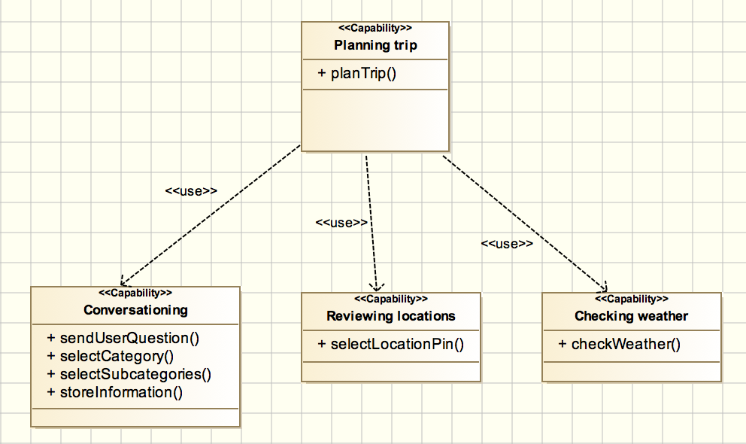

2.2. Service Interface Diagram

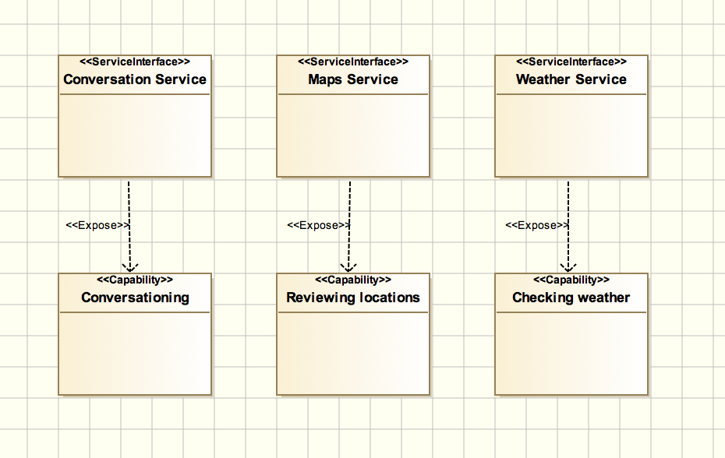

2.3. Service Contract Diagram

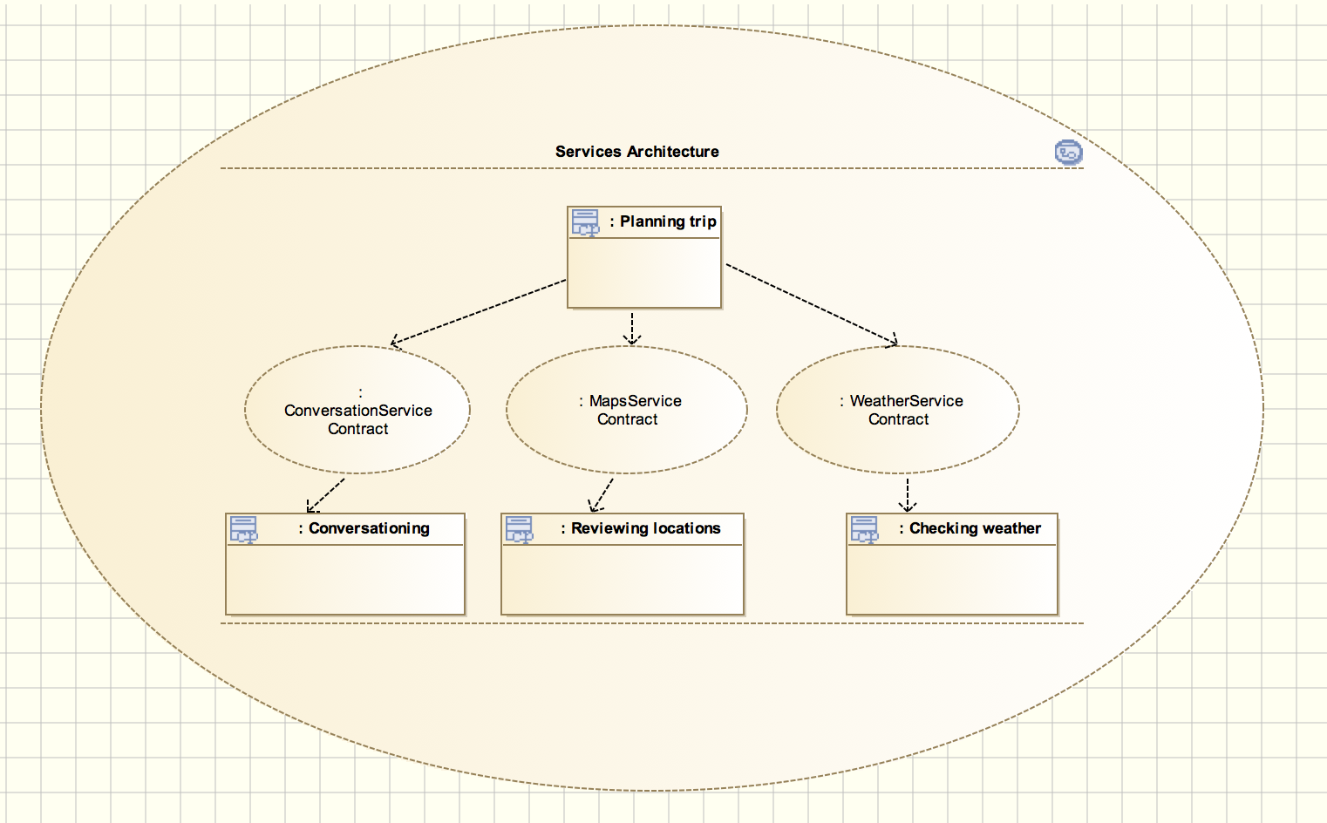

2.4. Message Diagrams

- Watson

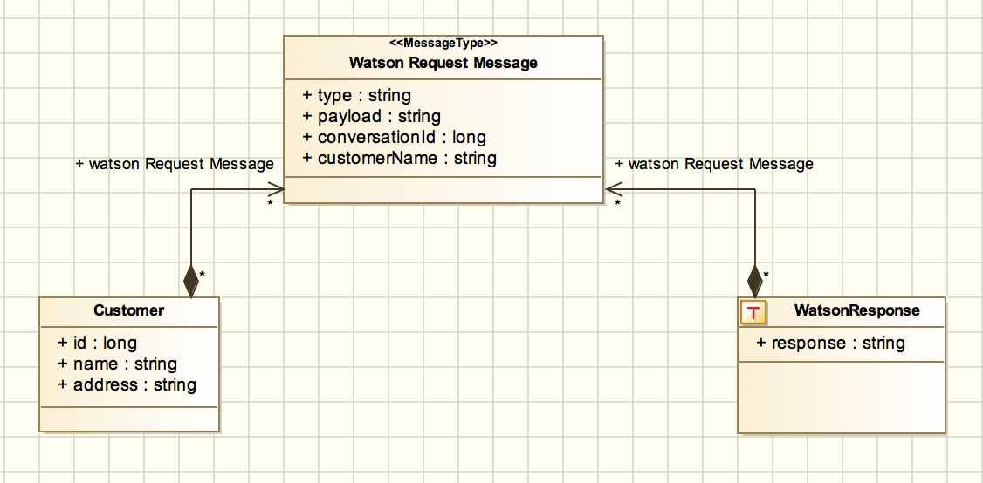

- Maps

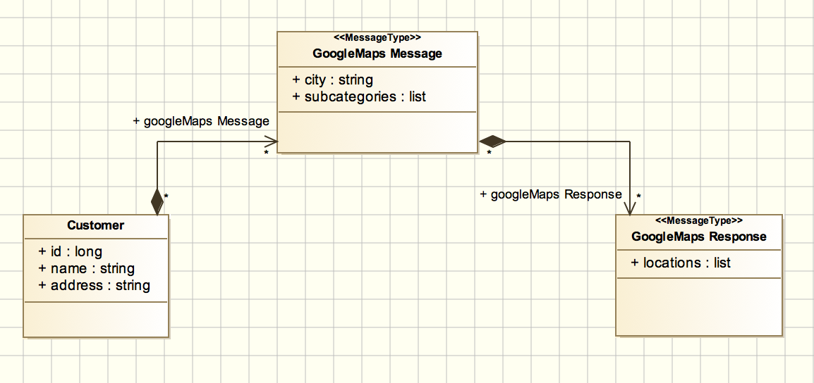

* + Weather

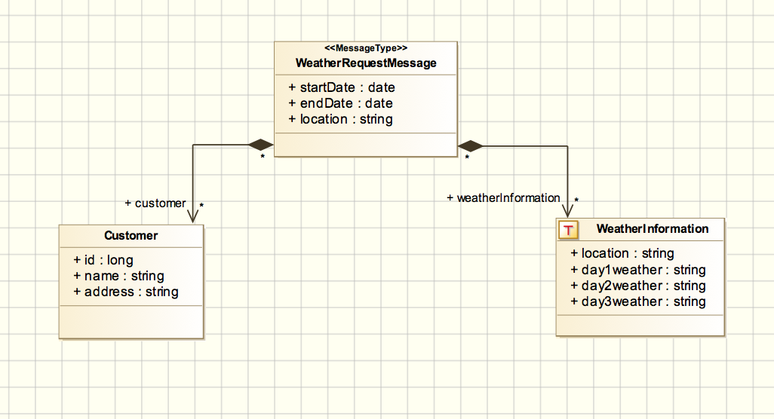

1. **BPMN process**

The BPMN process containing the interaction between the user and the external services (Watson, Google Maps, Weather) is presented in the following diagram:

